Attachment and Separation
Keyperson Role
Rachael Igbaroola

According to John Bowlby, attachment is
the connection a baby form with its
parent to ensure their basic needs of
safety, comfort, care, and pleasure are
met. He described this attachment as
“lasting psychological connectedness
between human beings”. Bowlby believed
that the style of the relationship between
the parent or other caregiver and the
child in this critical period of the baby’s
development becomes a blueprint for
later relationships.

A child needs to make a secure attachment with the main significant adult or adults in its life from a very early stage, and then have consistent and warm relationships from there onwards throughout childhood for emotional and psychological good health.

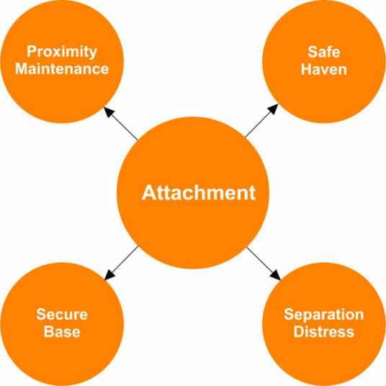

The main idea of attachment theory is that the caregivers provide the baby with a safe and secure base from which to explore the world. The baby knows that it is safe to venture out and explore the world, and that the caregiver will always be there to come back to for comfort in times of stress and discomfort.

“Children can form attachments with more than one caregiver, but the bond with the people who have provided close care from early infancy is the most important and enduring” (Bowlby, 1997).

Why is attachment important?

- The first two years of a child’s life are the most critical for forming attachments (Prior and Glaser, 2006).

- During this period, children develop an ‘internal working model’ that shapes the way they view relationships and operate socially. This can affect their sense of trust in others, self-worth and their confidence interacting with others (Bowlby, 1997)⁵

- Attachment is all about the development of an essential relationship with the primary caregiver as human babies are totally dependent on adults for their physical and emotional needs.

- Babies are born with immature brains. Their brain develops through early experiences and interactions including the responses made by the caregiver to requests from the child.

- Secure attachment to a caregiver ensures best chances of survival.

- Attachment is an adaptation to living in a dangerous/stressful/safe and social world).

- When attachment works well, the child has their overwhelming physical and emotional stresses regulated. This supports the development of a child’s sense of self, their expectations of social relationships and is how their psychology develops.

Types of Attachment

Secure attachment:
In secure attachment relationships, the caregiver is usually sensitive and tuned in to the child’s needs. They can provide care that is predictably loving, responsive and consistent. Babies/children who have formed a secure attachment to their caregiver may display the following patterns of behaviour during times of stress or exploration:
- proximity maintenance – wanting to be near their primary caregiver
- safe haven - returning to their primary caregiver for comfort and safety if they feel afraid or threatened
- secure base – treating their primary caregiver as a base of security from which they can explore the surrounding environment. The child feels safe in the knowledge that they can return to their secure base when needed
- separation distress - experiencing anxiety in the absence of their primary caregiver. They are upset when their caregiver leaves, but happy to see them and easily comforted when they return
(Ainsworth et al, 2015)
Benefits of secure attachment:
- When caregivers react sensitively to ease the child’s distress and help them regulate their emotions, it has a positive impact on the child’s neurological, physiological, and psychosocial development (Howe, 2011).
- Children with secure attachments are more likely to develop emotional intelligence, good social skills and robust mental health (Howe, 2011).

Insecure attachment:

Insecure/ambivalent: child learns that they are only sometimes loveable so work hard to please

Insecure/avoidant: child learns they are not loveable so hut down, retreat, make themselves invisible

Disorganised: child learns that to keep safe, the first response is to attack and then run away

Effects of insecure attachment:
- Not receiving comfort and security in the early years can have a negative effect on children’s neurological, psychological, emotional and physical development and functioning (Newman, 2015).
- Babies and young children who have attachment issues may be more likely to develop behavioural problems such as attention deficit hyperactivity disorder (ADHD) or conduct disorder (Fearon et al, 2010)
- Children who have attachment issues can have difficulty forming healthy relationships when they grow up. This may be because their experiences have taught them to believe that other people are unreliable or untrustworthy (Bowlby, 1997)
- Adults with attachment issues are at a higher risk of entering into volatile relationships and having poor parenting skills, behavioural difficulties and mental health problems (Howe, 2011)

The role of a keyperson:

The Keyperson system is a requirement of the Statutory Framework of the Early Years Foundation Stage which makes it mandatory for all settings to appoint a keyperson to support children at the nursery base on attachment theory.

The role of the keyperson is important as set out in the EYFS. It involves the keyperson responding sensitively to children’s feelings and behaviour and meeting their emotional needs by giving reassurance such as when they are new at the nursery and supporting their wellbeing.

The keyperson supports the physical needs too such as nappy changing, toileting, dressing, feeding and so on.

The keyperson is the familiar figure who is accessible and available as a point of contact for parents and one who builds relationships with child and parents.

Ways the keyperson can support:
Keyperson must know the importance of vertical and horizontal transition and support children using different strategies

Vertical transition

Horizontal transition

Vertical transitions are major changes that happens in a child’s life like starting nursery, moving from one room of the nursery to another or going to school. For children starting
nursery newly, practitioners can make this smooth for them and parents by:
- Doing a home visit before the child starts nursery
- Ask the parent to fill “All About Me” form which will give detail information about the child.
- Find out about family life, culture, celebrations
- Home language and toileting needs
- Settling in etc
- Use of comforter like blanket that helps the child to settle within first few sessions at the nursery etc

Horizontal transition involves the day-to-day changes to routine at the nursery like nappy changing, feeding time, nap time, singing time, garden time etc and practitioner must be aware of the support children need to make it through each day. The keyperson must device means to make every moment of this count by:

- The use of visual timetable
- Transitional toys
- Objects of reference
- Songs
- Time warning
- Key rings
- Reassurance and a good bond with the child

References:

Ainsworth, M.D et al (2015) Patterns of Attachment: a psychological study of the strange situation. New York: Psychology Press.

Bowlby, J. (1997) Attachment and Loss. Volume 1: Attachment. London: Pimlico

Fearon, R.P et al (2010) The significance of Insecure attachment and disorganisation in the development of children’s externalising behaviour- a meta-analytical study. Child development (8) 2

Howe, D. (2011) Attachment across the life course: a brief introduction. Basingstoke: Palgrave Macmillan

Newman, I. (2015) Attachment and early brain development: neuroprotective intervention in infant-care giver therapy. Translational development. Psychiatric (3) 1

NSPCC Learning [Online] Available @ https://learning.nspcc.org.uk/child-health-development/attachment-early-years#heading-top

Prior, V and Glaser, D. (2006) Understanding attachment and attachment disorder; Theory evidence and practice. London: Jessica Kingsley.

